**Using Mongo Atlas and Postman**

Be sure to download both MongoDB and Postman to use them. You will also need to have NodeJS downloaded to complete this process.

## Starting the Server

* In terminal cd into the “server” folder
* Enter “npm init”
  + This will install all the dependencies that are part of the JSON.Package
* Enter “npm run server”
  + This will use the server script to start the backend server
  + This one uses nodemon also so you can work on the program without having to restart the server

## Mongo Atlas

* To use Mongo Atlas you will need to add your IP address to Project 0
  + Log into Mongo Atlas
  + Open Project 0 by clicking on it
  + Select the Security tab
  + Select the IP Whitelist tab
  + Click the ‘Add IP Address’ button on the right side
  + Enter your IP Address and hit confirm
* You can now begin working with Postman to send requests to manipulate the DB
* Once you sent POST requests you can see the data in Mongo by going to the collections within Project 0

## Postman

* Open Postman
* Select what type of request you would like to make from the dropdown list (GET, POST, etc.)
  + Our API currently only has a GET and POST
* Enter your local server and the directory to access the API
  + <http://localhost:5000/api/habits>

### GET

* Once the address is entered, just click on Send
* If successful you will get a 200 response
* The results of the GET request will show at the bottom

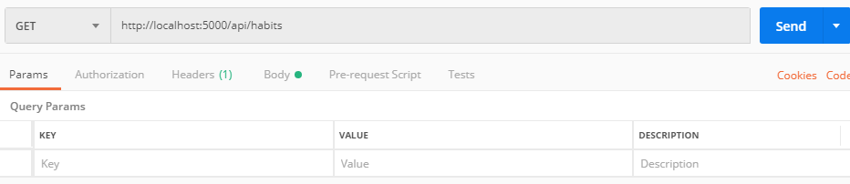

### POST

* Once the address is entered, you must also enter thedata you are trying to Post.
  + Click on the body tab right underneath the input field
  + Also be sure that “raw” and JSON are selected
  + Enter the data you would like to post in JSON format in the text field
  + Example:

{

"name": "Patrick",

"habit": "Exercise",

"smart": ["work hard", "eat healthy", "be efficient"],

"length": 30,

"intervals": "daily"

}

* + After data is entered click Send
  + If successful you will get a 200 response
* You can then go back to Mongo and check for the data by going to collections within the project

